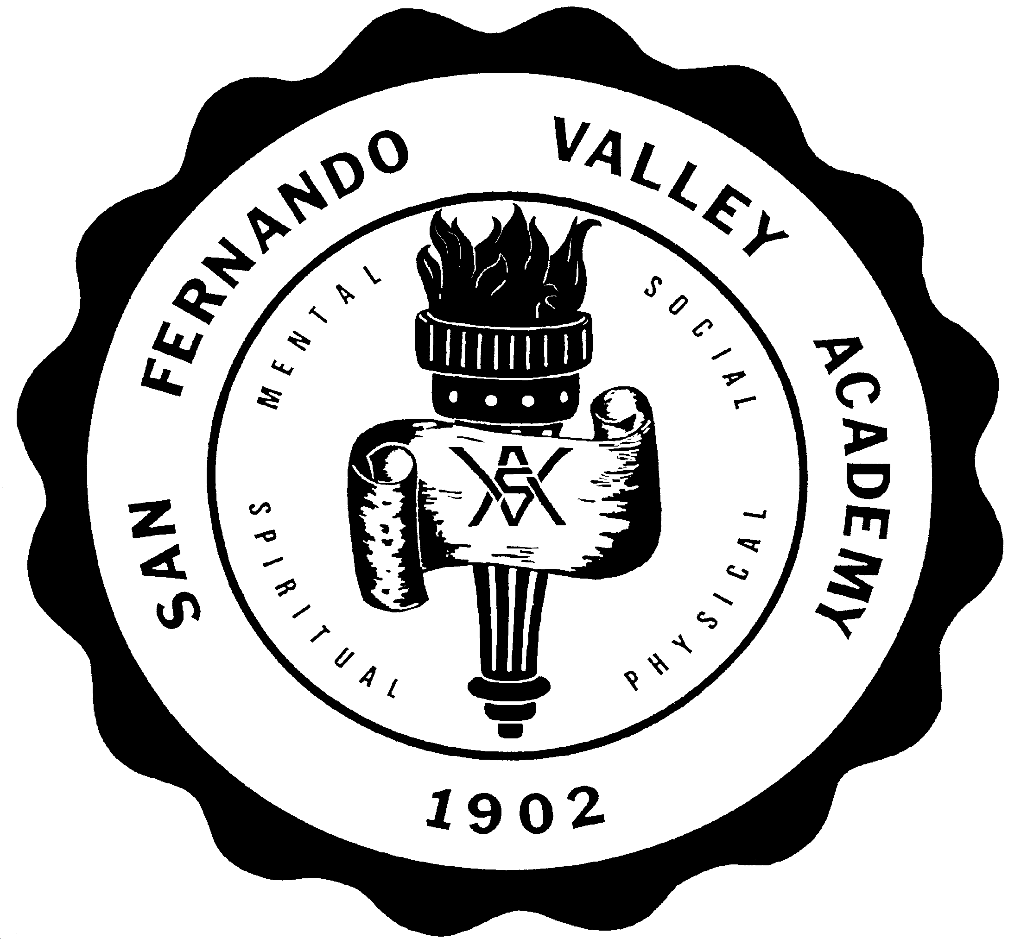**S A N F E R N A N D O V A L L E Y A C A D E M Y**

17601 LASSEN STREET, NORTHRIDGE, CA 91325

TEL 818-349-1373

FAX 818-773-6353

[WWW.SFVAHUSKIES.ORG](http://WWW.SFVAHUSKIES.ORG)

**NEW STUDENTS ONLY: STUDENT PROFILE**

**2023-2024 SCHOOL YEAR**

*(STUDENT’S HANDWRITING ONLY)*

1. Student’s Name

Last First Middle

1. Is it **your** personal desire to attend San Fernando Valley Academy? Yes No
2. IF ACCEPTED, what do you hope to receive from SFVA?
3. IF ACCEPTED, how will you contribute to SFVA’s positive school climate?
4. List any special honors or awards you have received:
5. Athletic Participation Survey:

Sports Played (e.g., Track)

Level

(e.g., Varsity)

Grade Played (e.g., 8th)

1. Activities and Fine Arts Participation Survey:

Activity Participation (eg. ASB)

Grade Participated

Fine Arts (eg Band)

Grade Participated

1. Have you had difficulties with students, teachers, or subjected to major school discipline? Yes___ No____ Please explain.
2. Are you a baptized member of the Seventh-day Adventist Church? YES____ NO____
3. Are you active in your local church? Yes No Name of Church? Please list the church activities in which you and your family participate:
4. Please explain how your religious faith shapes who you are as a person:

**Student’s Signature Date**