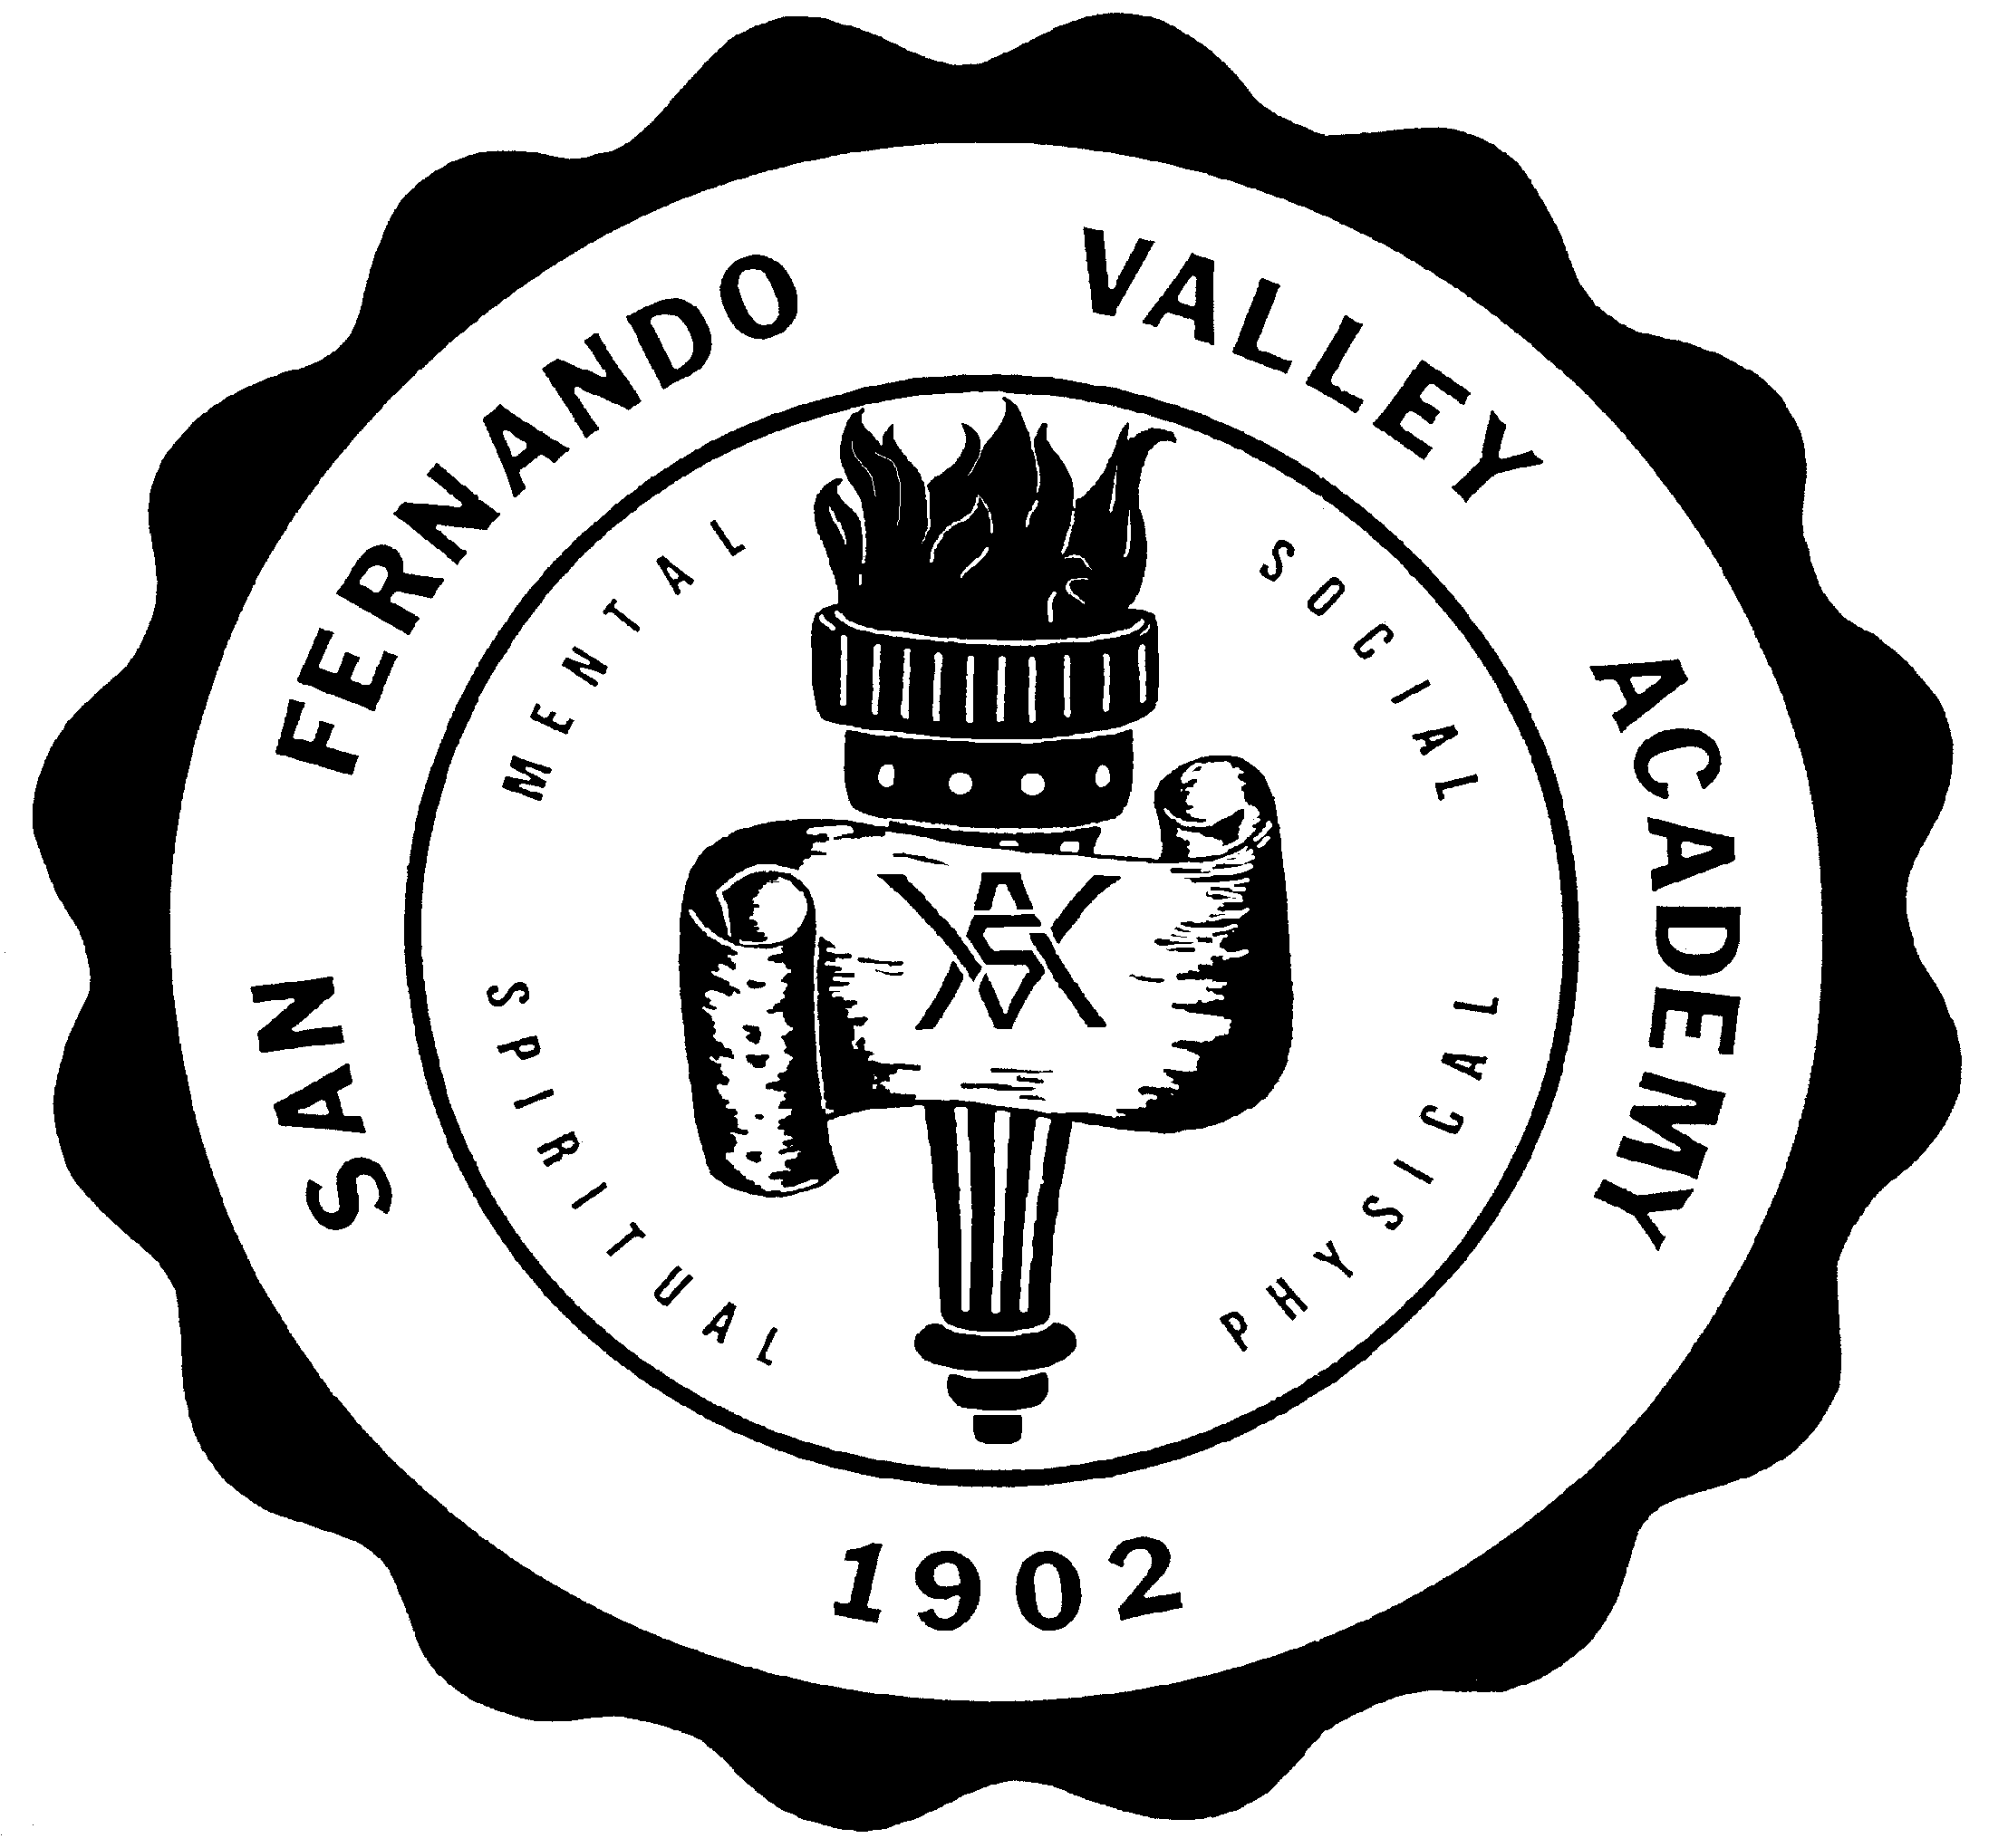**S A N F E R N A N D O V A L L E Y A C A D E M Y**

17601 LASSEN STREET, NORTHRIDGE, CA 91325

TEL 818-349-1373

FAX 818-773-6353

[WWW.SFVAHUSKIES.ORG](http://WWW.SFVAHUSKIES.ORG)

**PARENTAL MEDIA RELEASE FORM**

**2023-2024 SCHOOL YEAR**

PARENTAL RELEASE FOR INTERVIEWING, PHOTOGRAPHING,

AND VIDEOTAPING/AUDIO-RECORDING OF STUDENTS

Student’s Name: Grade

We are the parents/guardians of , who is currently enrolled as a student at San Fernando Valley Academy (“SFVA”). I recognize that as part of the educational process, there may be times when SFVA, or someone properly authorized by SFVA, such as media representatives, may want to interview, photograph, audio-record and/or videotape my student during regular school hours on school grounds, and/or at student activities.

Our signature grants of permission means that, in addition to other appropriate uses (which include, but are not limited to, inclusion in or on SFVA publications, promotional materials, advertisements, presentations, programs, and Internet/Intranet sites), information obtained from the student and the student’s likeness and name may be used in conjunction with or by any medium, including print, electronic, radio, and television.

The purpose for which this release, may be used and the procedures relating to its use are governed by all pertinent SFVA policies, procedures, rules, and regulations.

The school shall retain the negative(s), positive(s), digital image(s), or any of other format of said photograph(s) as its own property.

Furthermore, the undersigned consents to the use of said photograph(s) and any format of them prior to their use.

If the undersigned is under the age of eighteen (18), his/her parent or legal guardian has read and understands the foregoing and consents to all the terms herein.

By signing this Release, I waive any cause of action I may have, or that the student may have, against SFVA pertaining to the reproduction, publication, and/or use of information obtained from the student and/or the student’s name or likeness. I acknowledge that I may revoke this release at any time during the school year by mailing or delivering a written notice of revocation to my student’s principal at San Fernando Valley Academy – 17601 Lassen Street, Northridge, CA 91325.

The student is under the age of eighteen (18) and the undersigned is his/her parent or legal guardian and approves and consents to all of the foregoing.

Signature:

Mother’s Name: Date

Signature

Father’s Name Date