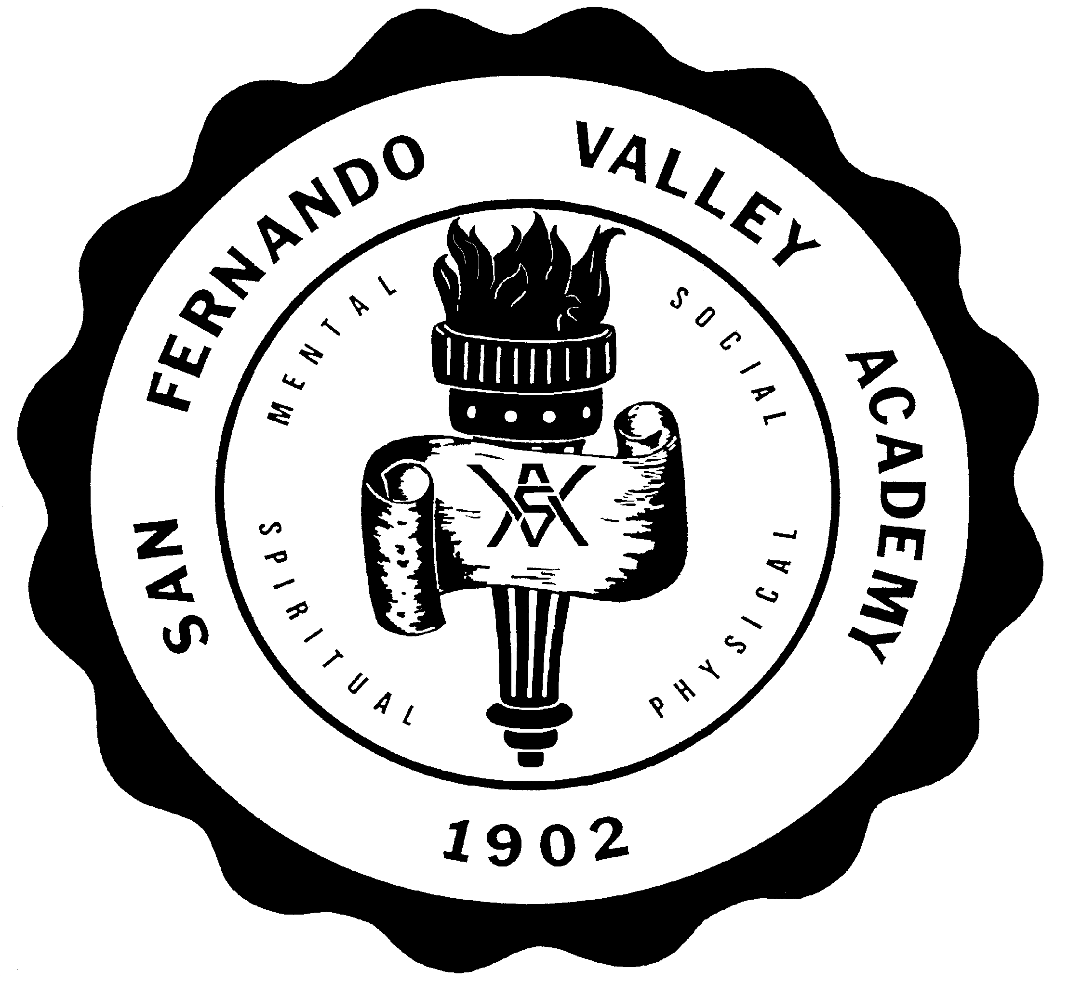**S A N F E R N A N D O V A L L E Y A C A D E M Y**

17601 LASSEN STREET, NORTHRIDGE, CA 91325

TEL 818-349-1373

FAX 818-773-6353

[WWW.SFVAHUSKIES.ORG](http://WWW.SFVAHUSKIES.ORG)

**PARENT AND STUDENT PLEDGE OF COOPERATION**

**2023-2024 SCHOOL YEAR**

**PARENT PLEDGE:**

I am fully acquainted with and agree to follow the regulations of San Fernando Valley Academy as outlined in the Parent-Student Handbook 2023-2024. I will cooperate with the school and help my child abide by these regulations.

PARENT’S SIGNATURE DATE

**STUDENT PLEDGE:**

It is distinctly understood that every student who presents themselves for admission to San Fernando Valley Academy thereby pledges to observe the Christian principles upon which this academy is operated, whether on or off campus. If the pledge is broken, it is also understood that he/she forfeits his/her enrollment. It is also a part of the student contract that he/she will, to the best of his/her ability, perform all duties assigned to him/her in connection with the academy. The student signs the pledge below stating compliance with the above upon entrance.

I am fully acquainted with and agree to follow the regulations of San Fernando Valley Academy as outlined in the Parent-Student Handbook 2023-2024. I will abide by them. Furthermore, I understand that failure to abide by these regulations may lead to my dismissal from school.

STUDENT’S SIGNATURE DATE