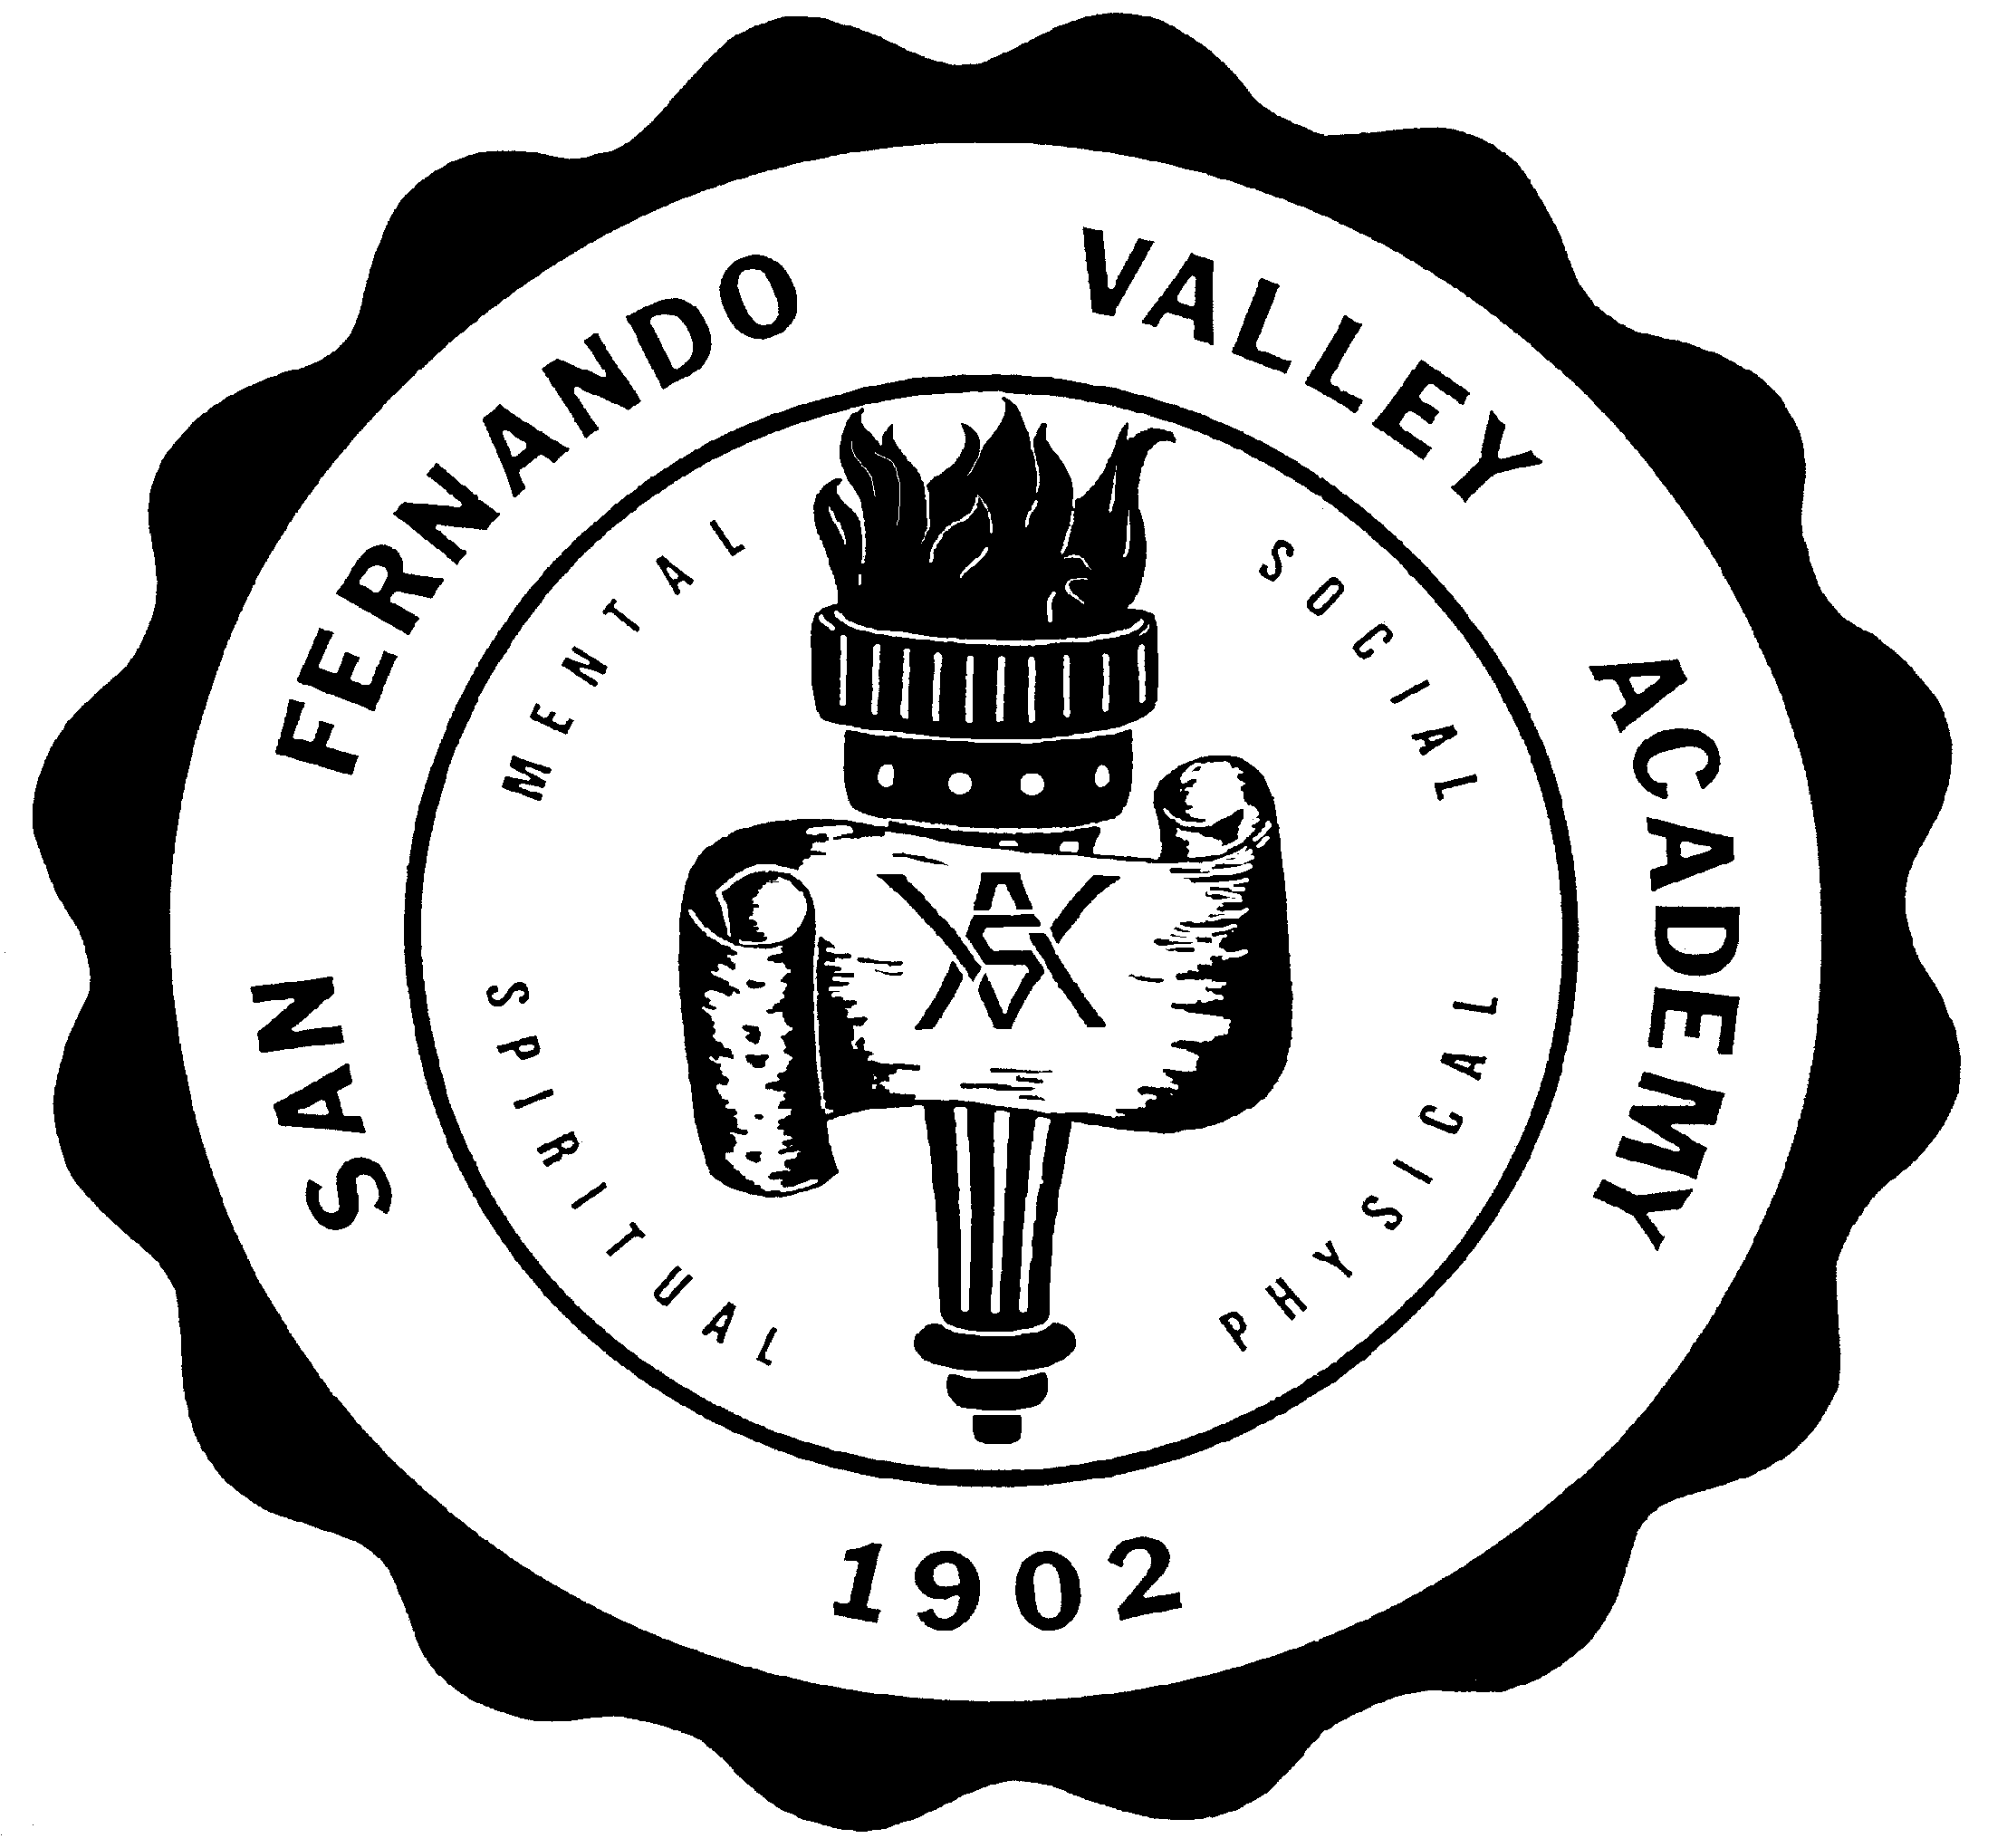**S A N F E R N A N D O V A L L E Y A C A D E M Y**

17601 LASSEN STREET, NORTHRIDGE, CA 91325

TEL 818-349-1373

FAX 818-773-6353

[WWW.SFVAHUSKIES.ORG](http://WWW.SFVAHUSKIES.ORG)

**HOME AND SCHOOL ASSOCIATION**

**2023-2024 SCHOOL YEAR**

Student’s Name Grade

The *Home and School Association* is a group of parents that support SFVA in many different ways throughout the school year. When you register your child at SFVA you will automatically become a member of the Home and School Association

As a member of the *Home and School Association* you will be invited to participate in many activities during the school year. This will include helping the teacher in your child’s class or classroom during parties, field trips, picnics, and other outings. You will also be asked to help with fund-raisers and school promotions. You may become an organizer of Home and School events.

At the beginning of the school year you will be asked to volunteer for various activities during the semester or school year. As a volunteer you become an important asset in the school and its activities.

If you would like to become a volunteer for our *Home and School Association* please indicate below in which activities or events you are able to help:

Direct Traffic

Prayer Team

Classroom Parent

Fundraising

Playground Duty

Teacher Appreciation

International Fair

Tardy Monitor

Other

Please indicate days and hours when you are available to volunteer:

Parent Name Street Address City/State/Zip Code Home Phone Work Phone Cell E-mail address

Parent’s Signature Print: _____________________________